Objective
To compute the sum of squares of a large range of numbers using:
- Single-threaded approach
- Multithreaded approach
Write a C++ program to calculate:
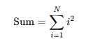
Where N is a large number (e.g., 2^10 or more).
Tasks:
- Implement the calculation using a single loop
- Implement the same using multiple threads
- Measure and compare execution time for both approaches

